Oxford Owl Ebooks: Reading At Home
You can read books online at home using this website and then quiz on them on Accelerated Reader. Simply click on the link below and follow the instructions on this page to help you.

https://www.oxfordowl.co.uk/for-school/oxford-owl-ebook-collection?utf8=%E2%9C%93&query=&age_group=age+7-9&series=&level=&book_type=&view_style=image#
Click on this!
Username:
Password:

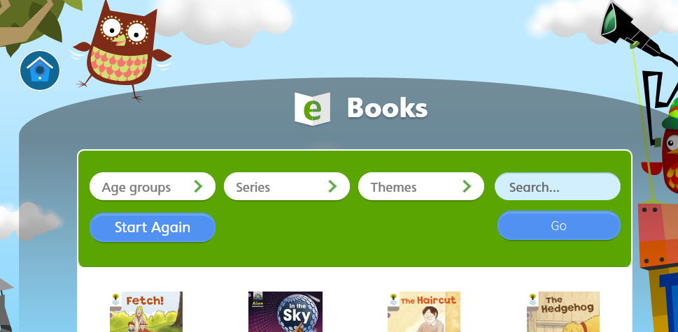

Accelerated Reader Levels
Choose an ebook that matches your Accelerated Reader ZPD, based on the list here, on the left. You can search for the book you want to read, here…

When the book you choose pops up, move the mouse to the right of the cover, as if you are going to turn it over. Click and the page will turn! It will do this for each page, until you reach the end of the book.

Green - 0.0 - 1.9
The Toys' Party - 0.4
Spots! - 0.5
The Ice Rink - 0.6
Stuck in the Mud - 0.7
By the Stream - 0.7
The Snowman - 0.8
The Noisy Day - 0.9
The Birthday Cake - 1.0
the Scarf - 1.1
Everyone Got Wet - 1.1
Goal! - 1.2
Sue Kangaroo - 1.2
Flying High - 1.4
Patterns - 1.4
Ballet - 1.4
You need to read the book yourself to quiz on it. If you want to listen to it (by pressing the triangular play button next to ‘Audio’, you cannot quiz on it.
You can always listen to it AFTER you have quizzed!

Kipper and the Trolls - 1.6
A Monster Mistake - 1.6
The Orchid Thief - 1.8
Animal Magic - 1.9

Orange - 2,0-2.9
Christmas Adventure - 2.1
Tiger's Discovery - 2.1
Paris Adventure - 2.2
key trouble - 2.3
The Magic Paintbrush - 2.3
Julia Donaldson: A Biography - 2.3
Oh, Otto! - 2.3
When Animals Invade - 2.4
Red Planet -2.4
Attack of the Centipede - 2.4
The Flying Machine - 2.5
The Frog Prince - 2.5
What was it like? - 2.6
Jellyfish Shoes - 2.6
Happy Birthday, Winnie - 2.6
Escape of the Giant Chicken - 2.7
Power Racers - 2.7
Cool Clive - 2.7
Stinky street - 2.8
Here Comes Trouble - 2.8
Here Comes Trouble - 2.8
Dinosaur Safari - 2.9
Finn MacCool - 2.9
Eric's Talking Ears - 2.9

Blue - 3.0-3.9
20,000 Leagues Under the Sea - 3.0
the Boss Dog - 3.0
Wild Weather - 3.1
Jungle Shorts - 3.2
The Lazy Giant - 3.3
The Crystal Planet - 3.4
Sport Then and Now - 3.4
Things that Sting - 3.4
Captain Comet and the Purple Planet - 3.4
Cornflake coin - 3.4
The Personality Potion - 3.4
How the World Began - 3.5
Nelly the Monster Sitter - 3.5
How the World Began - 3.5
Clever Monkey - 3.5
Ultimate Takeover - 3.5
Tom Thumb and the Football Team - 3.5
Rumpelstiltskin - 3.6
Animal Tricksters - 3.6
Dick Whittington - 3.7
Air Raid! - 3.7
East of the Sun, West of the Moon - 3.8
Doohickey and the robot - 3.8
Journey to Mars - 3.8
Brer Rabbit's Trickbag - 3.9
The Huge Horrible Beast - 3.9

Yellow - 4.0-4.9
What's Inside Me? - 4.0
Air Raid! - 4.1
Stories of Sherlock Holmes - 4.1
White Fang - 4.1
Grace the Pirate - 4.1
Fables from Africa - 4.2
Storm Chasers - 4.2
Tales of the Underworld - 4.3
Treasure Island - 4.5
Black Beauty - 4.5
Mythical Beasts and Fabulous Monsters 4.6
Downhill Racers - 4.9

Red - 5.0-5.9
Making a book - 5.0

Black 6.0-6.9
Exploring the Deep - 6.5

